INTRODUCTION

Problem Statement: Prospect of a bakery close to the residential and crowded areas in Toronto city, Canada.

Canada immigration is considered one of the best in the world as it is loaded with better opportunities for employment as well as personal growth. It is indeed a country for those in search of a better quality of life.

My friend is moving to Canada. She is from a business background and business is her passion too. She is also a wonderful baker. She wants to open a bakery. People like to celebrate each happy moment in their life. Cakes are loved by most people and are part of every celebration whether it’s your kid's birthday, a salary hike, a job offer, a trophy in school sports day. The bakery should be located in a busy area and preferably close to residential area. Toronto is made of many neighborhoods but she will concentrate on the busiest neighborhoods. Downtown Toronto, West Toronto, Central Toronto and East Toronto are business friendly places. Using Foursquare location data, I can analyze the places. She has to select a busy area with least number of bakeries so that the competition will be less.

Target Audience

1.Business people who wants to invest or open a new bakery. This analysis will be a guide to start a bakery targeting people at all ages.

2.Residents

They will be interested to find an affordable and fresh bakery in the neighborhood.

2.Tourists

Tourists will be interested to find the little warm places to have a quick bite.

DATA

DATA PREPARATION

WIKIPEDIA.

The data of Toronto neighborhoods I use is acquired from Wikipedia pages. This has been worked out in the lab section.

https://en.wikipedia.org/wiki/List_of_postal_codes_of_Canada:_M.I will use pandas to scrap the data frame from the wiki page.

GEOPY CLIENT

To get the coordinates of the neighborhoods I use geopy client. If that is not working properly, I will use this csv file to get the coordinates, https://cocl.us/Geospatial_data.

FOURSQUARE LOCATION DATA

I will be using Foursquare data for segmenting and clustering. Using Foursquare API, we will find the popular spots and bakeries in each place. The popular spots returned depends on the highest foot traffic and thus it depends on the time when the call is made. So, we may get different popular venues depending upon different time of the day.

Approach

* Collect the Toronto city data from https://en.wikipedia.org/wiki/List_of_postal_codes_of_Canada:_M.
* Using Foursquare API, we will find all venues for each neighborhood.
* Filter out all venues that are Bakery.
* Find the count of bakery in each neighborhood.
* Count residences and schools in each neighborhood as they are good target customers.
* Find the best place to open the bakery using these data.
* Visualize the neighborhood using folium library.

METHODOLOGY

• For each locality, all residences, schools, universities and bakery venues data have been collected from Foursquare.

• Then for each locality, the sums of the residences, school and bakery were computed.

• For each of these 4 categories, a weight (or penalty) has been defined.

• Bakeries have been weighted with -1, to avoid concurrence.

• Schools have been weighted with 1, since student are good customers.

•College & Universities have been weighted with 2 as they are also good customers

• Residential areas have been weighted with 3, since residents are even better customers.

• Lastly, a score was computed for each locality as the weighted sum of the number of venues in each of the 4 categories.

Toronto Neighborhoods

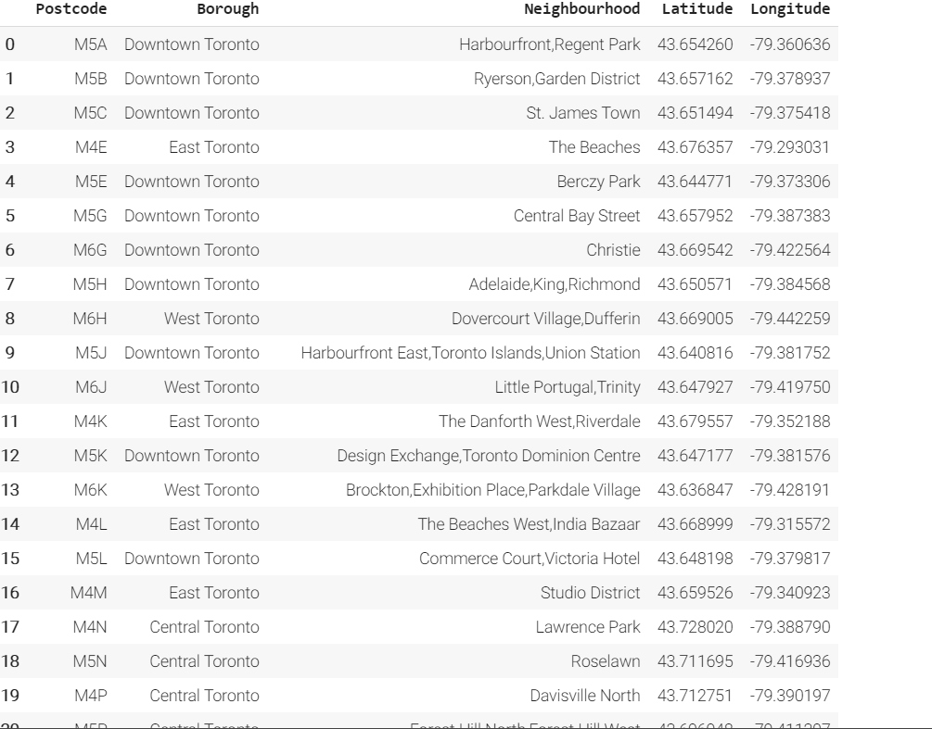

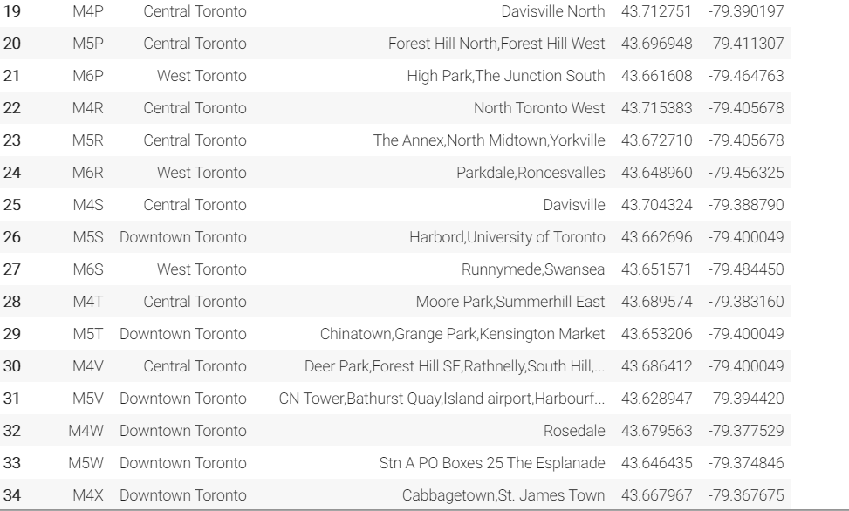

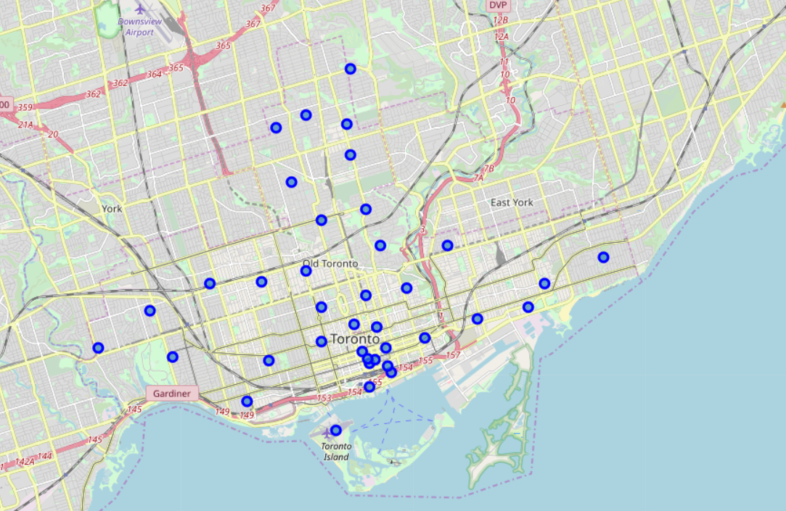

Bakeries in the neighborhoods

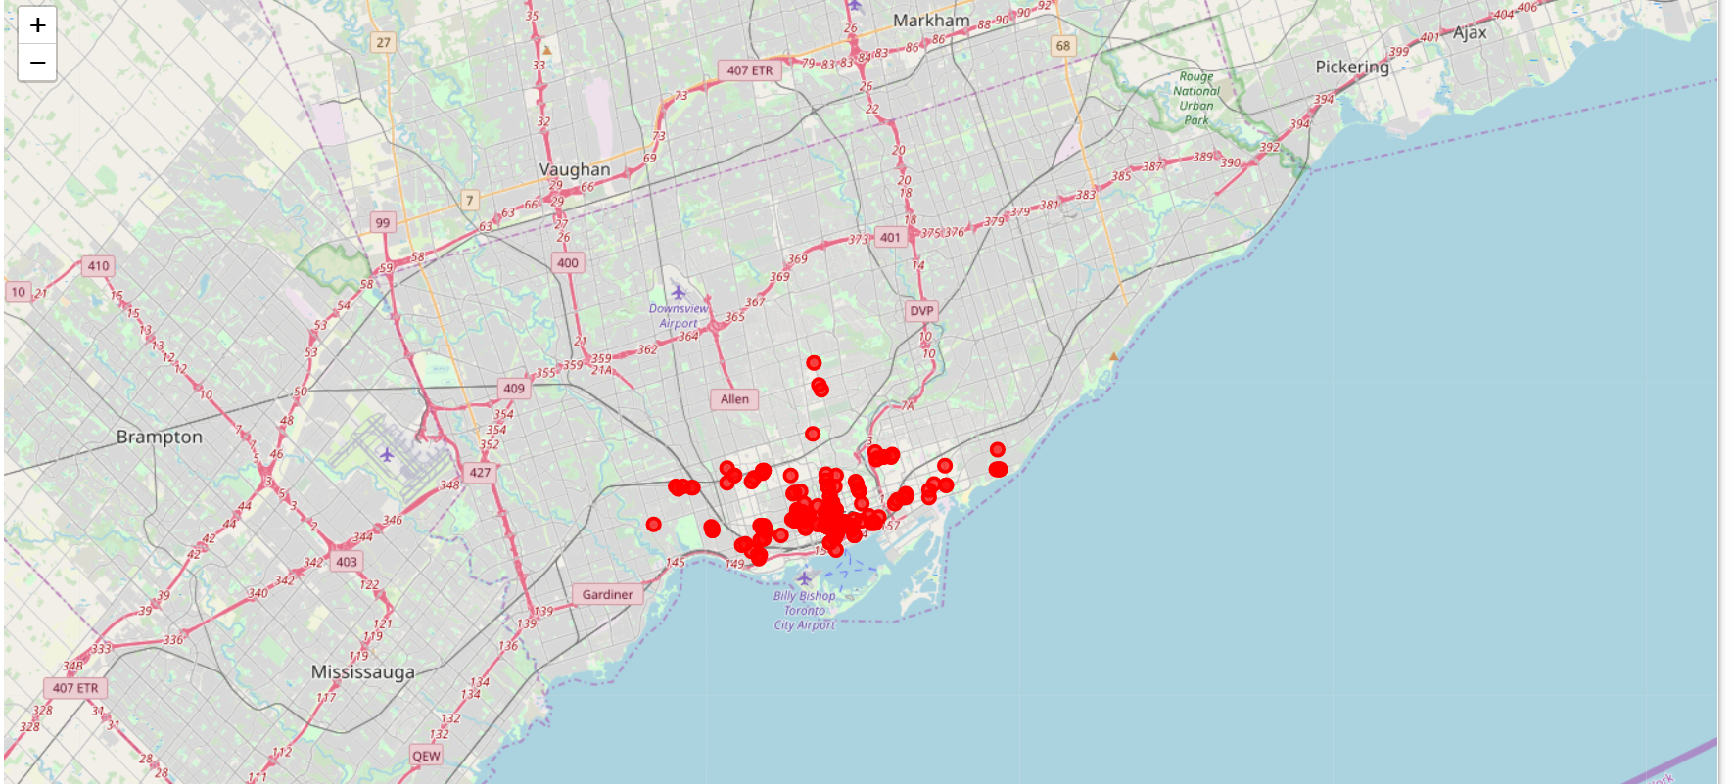

Schools in the neighborhoods

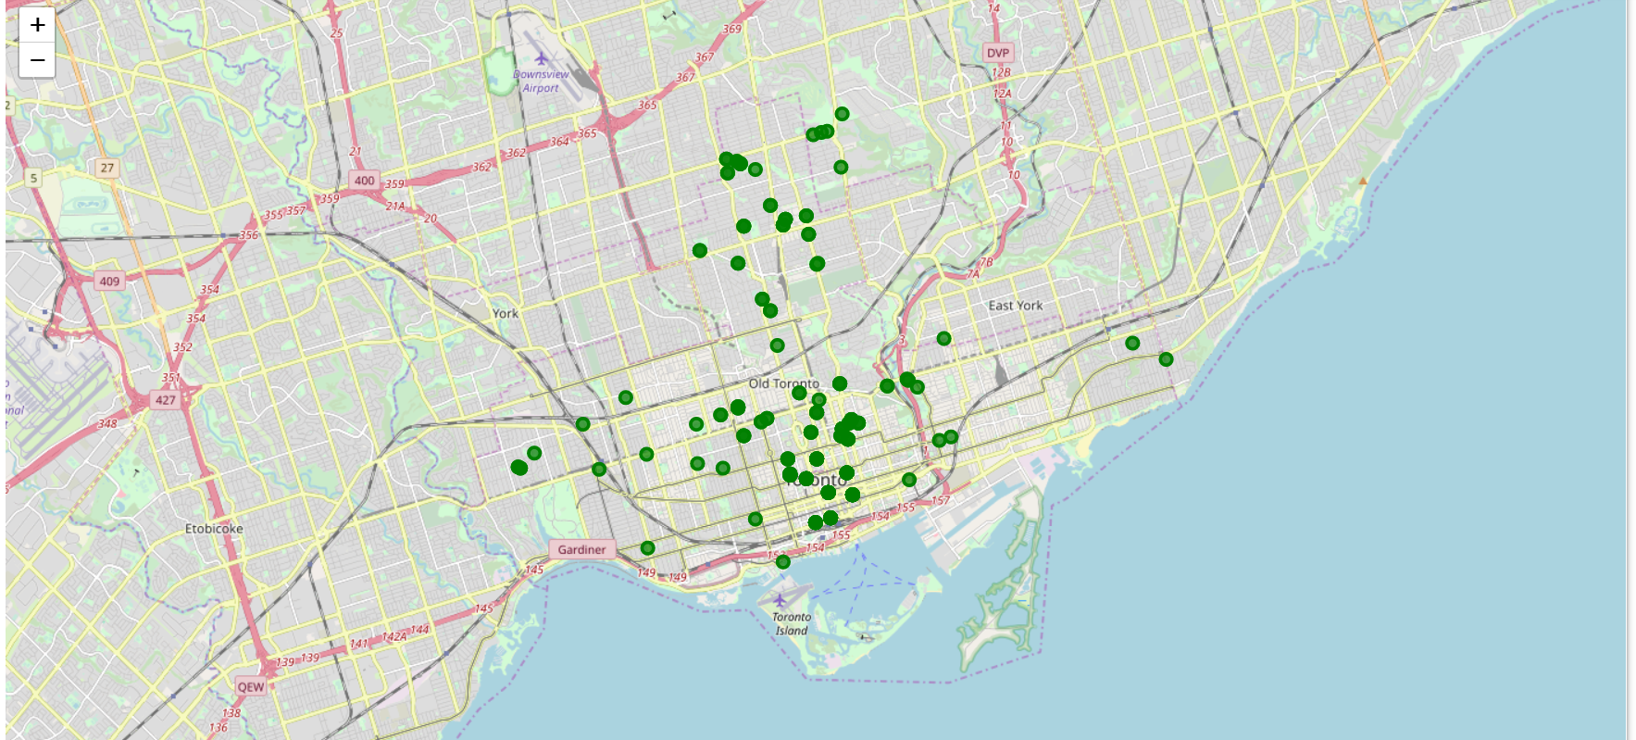

College & Universities in the neighborhood

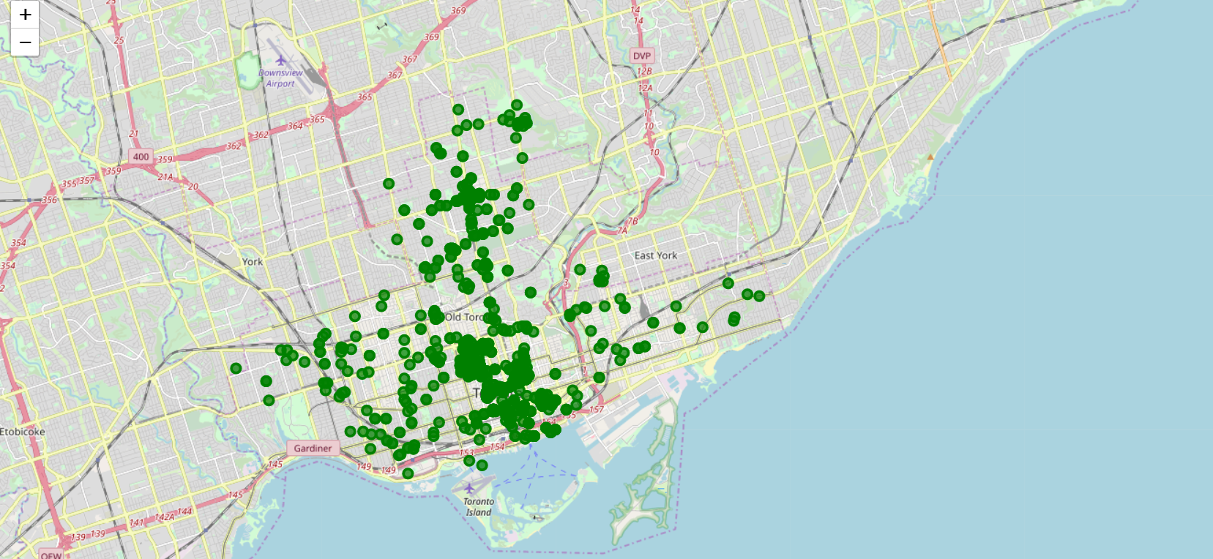

RESULTS

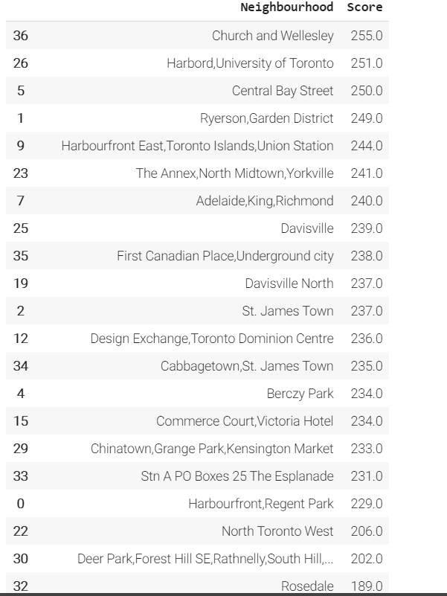

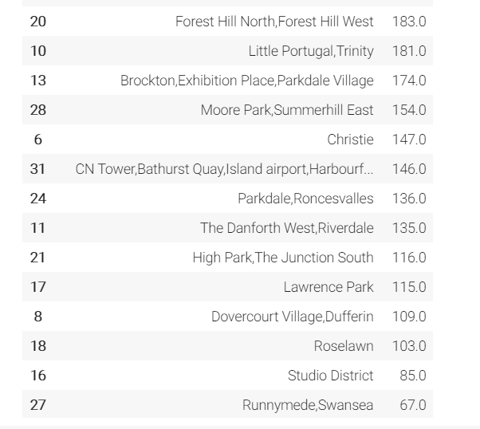

• The Locality with the best score is “Church and Wellesley” with 255.0, being the best option.

•Second option is “Harbord University of Toronto” with 251.0.

These options maximize the number of potential customers from residential areas and schools and at the same time have not too large competence.

Best location for bakery in Toronto is Church and Wellesley

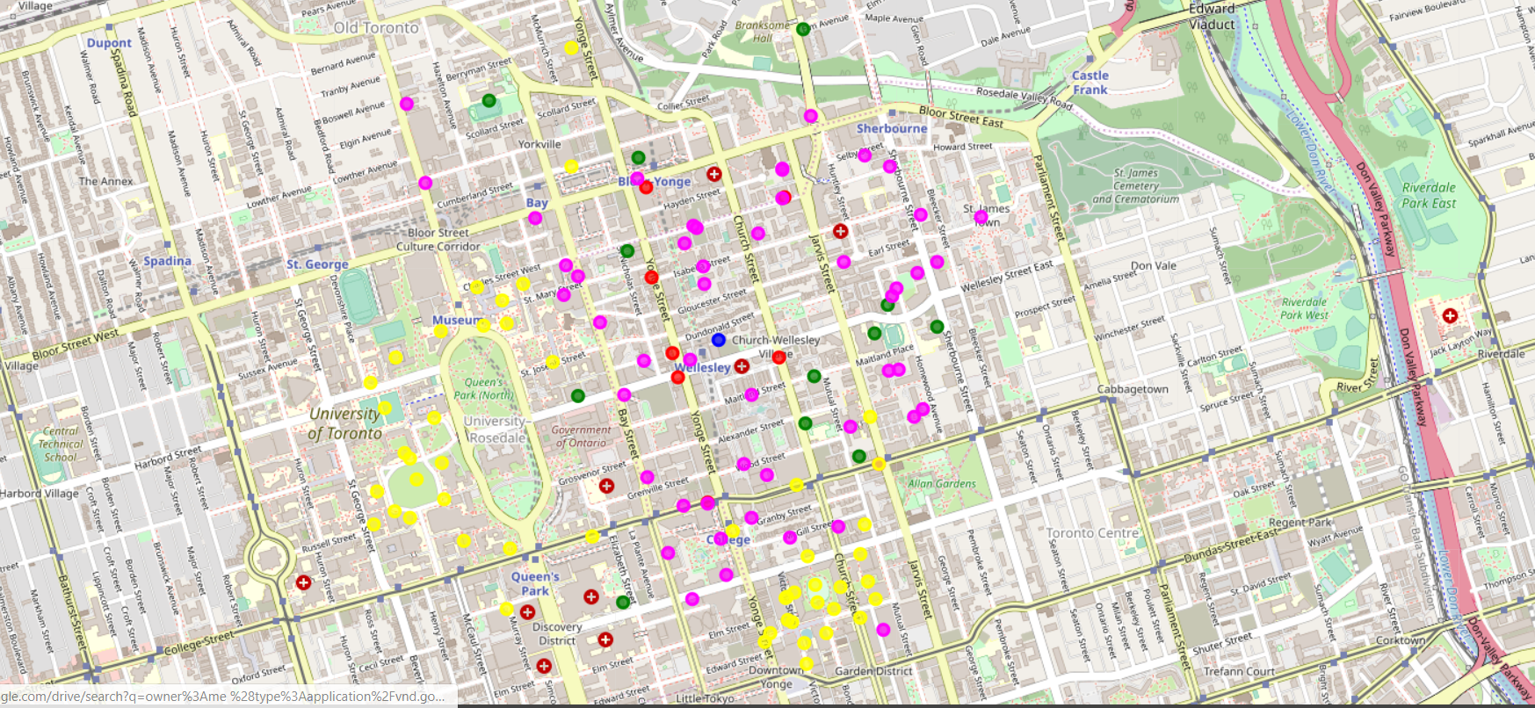

DISCUSSION

The following analysis can be improved with following extensions:

• We can consider more categories. For example, “train stations" are busy areas and a good source of customers. But closeness to restaurants is not preferable.

• In the Locality itself, it can also be computed the distance between all the venues in order to find a place with the greatest number of potential customers.

• Using smaller geographical areas like Neighborhoods could improve the accuracy for the scores.

CONCLUSION

Using data analysis, I found out that Church and Wellesley is the best neighborhood to open a bakery in Toronto. I will advise my friend to explore that area and find a good spot.